**Linux Operating System (USCS103)**

**Practical 5:**

**Installation of Ubuntu Linux operating system.**

|  |
| --- |
| **Learning Objectives**    *Students will be able to:*  **Content:**   * Learn the steps for Ubuntu installation.   **Process:**   * How to install Ubuntu Linux operating System.   **Prior Knowledge:**   * Basic Knowledge of Linux Operating system |

**Installation Steps for Ubuntu:**

**Step 1:**

|  |
| --- |
| Download Ubuntu 16.04 from the official website “https://ubuntu.com/”, put the CD(iso) into the CD-ROM drive, change the boot sequence so that CD-ROM can boot first. If you want to install Ubuntu from the USB flash Disk, change the boot sequence according to the USB mass storage to boot first. |

**Step 2:**

|  |
| --- |
| Press Enter to get a language screen and then select the language of your choice. |

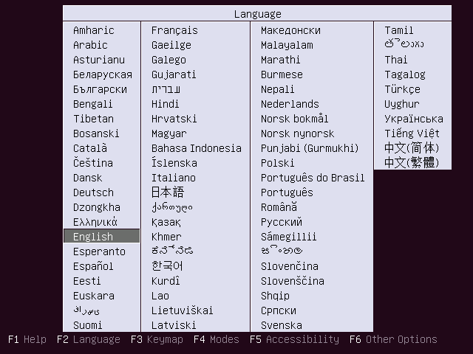

**Step 3:**

|  |
| --- |
| For installing Ubuntu 16.04, Select Install Ubuntu.This is a starting screen, it will disappear in a minute |

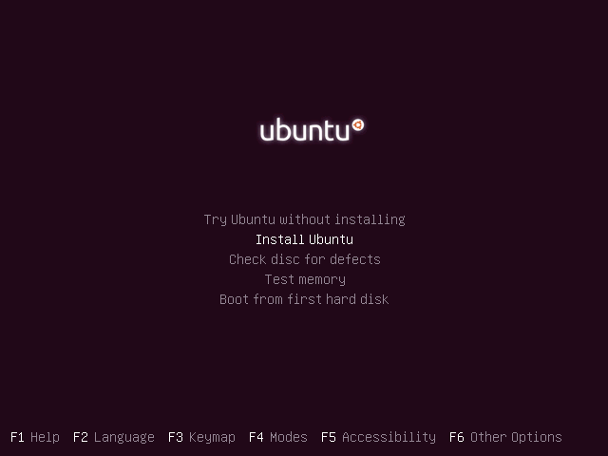

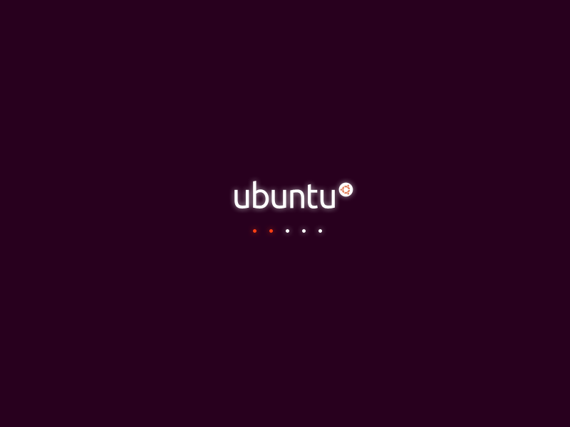

**Step 4:**

|  |
| --- |
| Click “continue” on the welcome screen. |

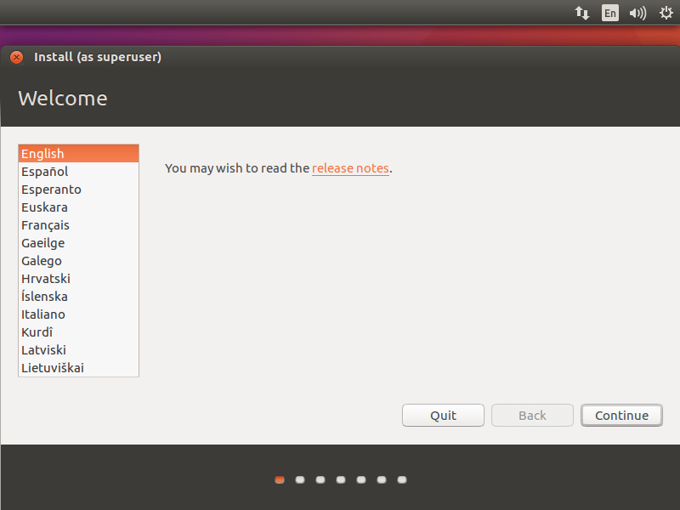

**Step 5:**

|  |
| --- |
| You can either choose to install updates and other third-party software while installing Ubuntu 16.04 or leave as it is since it requires internet and installation may take an hour- long depends on the downloadable contents. |

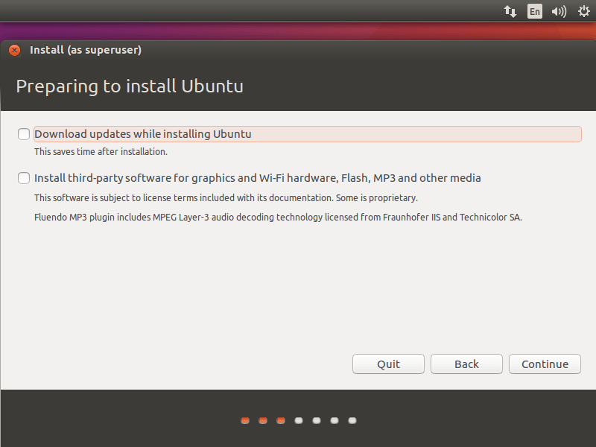

**Step 6:**

|  |
| --- |
| Next is the installation type, this installation on the fresh HDD so I have only two options in the installation type. Depending on the other OS on your HDD you will get more options. Please choose any one of the methods. ” Erase disk and install Ubuntu” (i.e. it will  format the entire drive and install the OS). If you don’t have any idea about the partitioning  scheme simply click on Install Now. |

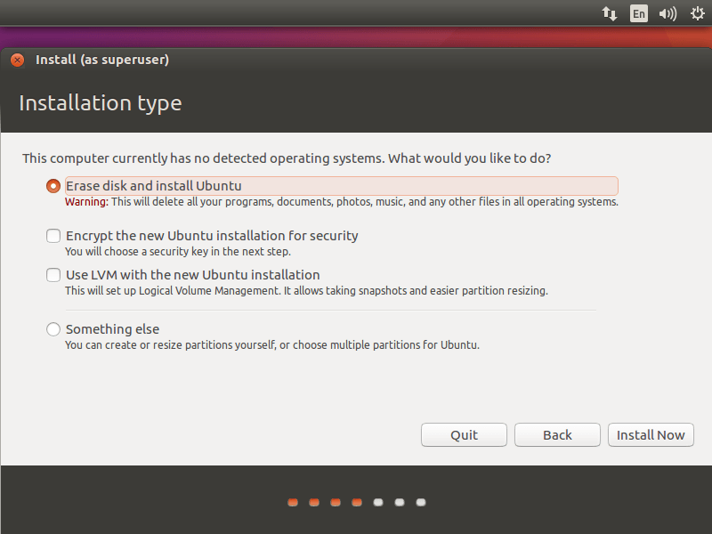

**Step 7:**

|  |
| --- |
| Once you click on Install Now, the installer will ask you to confirm the auto partitioning. Click on continue. |

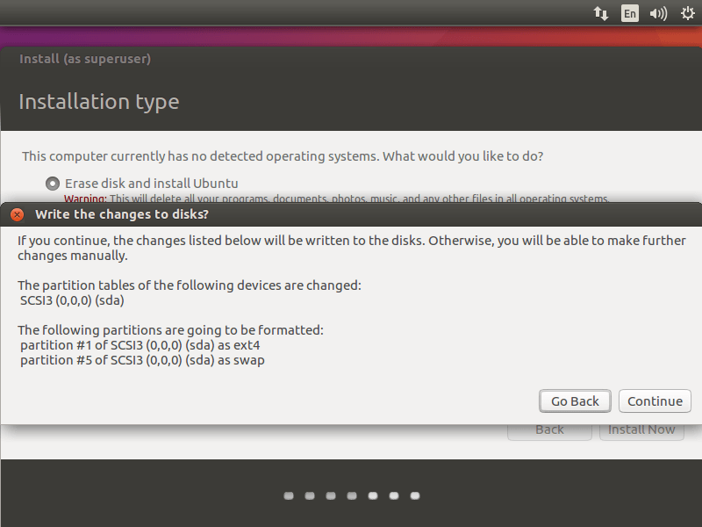

**Step 8:**

|  |
| --- |
| - Something else (i.e. you can manually create the partition and install Ubuntu on your selected partition), use this advanced mode if you are comfortable in partitioning your drives manually. Click on continue. (This step is not necessary if you have already performed step 6. This step is only for those users who are comfortable with making partitions or wish to create a partition in their hard disks for this new OS) |

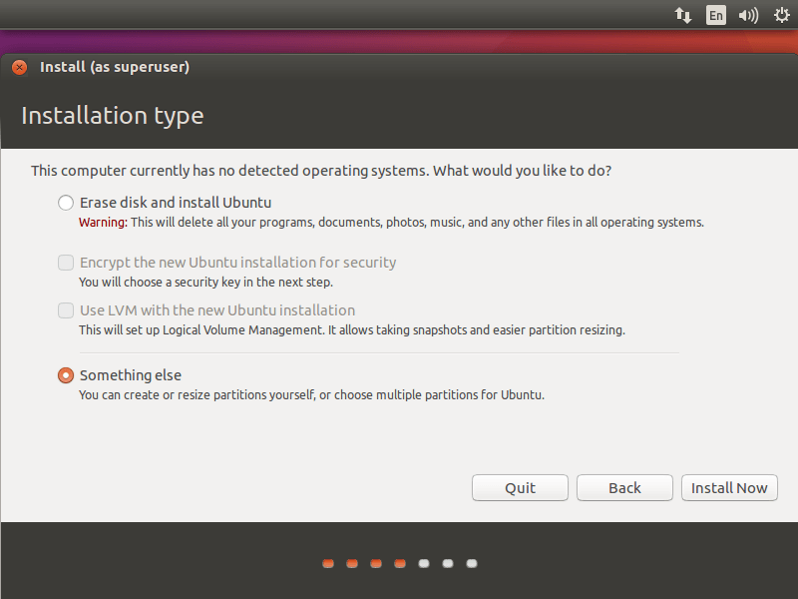

**Step 9:**

|  |
| --- |
| Following shows  for /boot partition.Once you clicked, you would get the following page where installer lists available hard disk. In my case I have one hard disk size of 100GB, to create a partition; click on New Partition Table to create an empty partition.  Since this is a new hard disk. Pop up will ask you to confirm, click on continue.  Partition scheme will be like below:  /boot – 500MB  swap – 2048MB  Remaining (99GB)  Select free space and click on the + sign at the bottom to create partitions. |

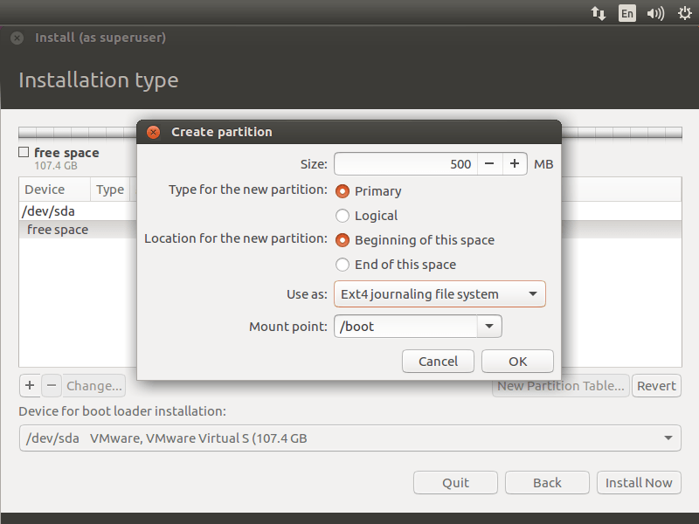

**Step 10:**

|  |
| --- |
| Following screen show for the swap partition, it is important to select use as swap area. |

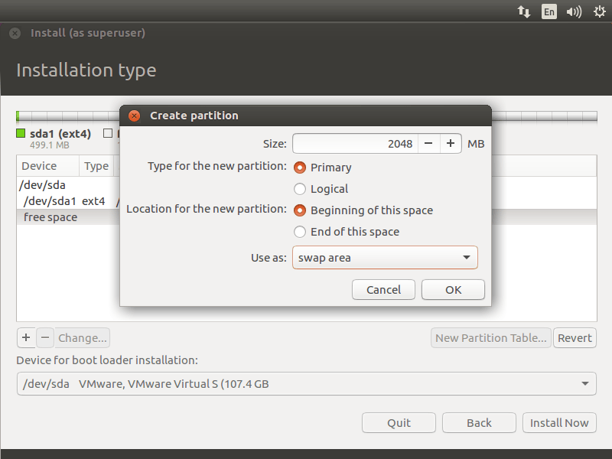

**Step 11:**

|  |
| --- |
| Following is for / (root) partition. |

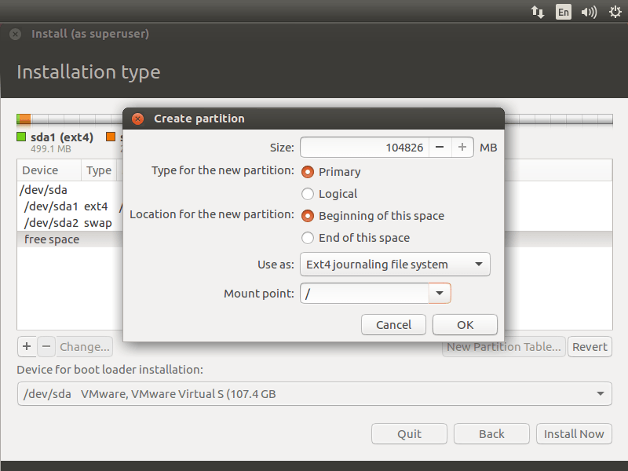

**Step 12:**

|  |
| --- |
| Review your partition layout and click on install now. |

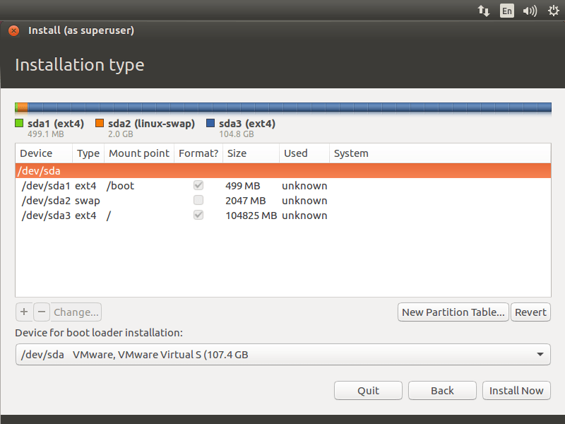

**Step 13:**

|  |
| --- |
| Write the changes to disk by clicking on continue. |

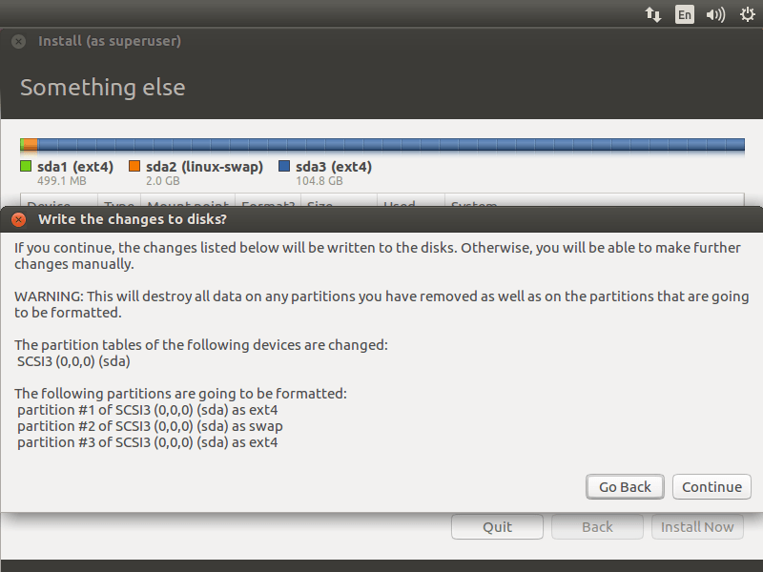

**Step 14:**

|  |
| --- |
| Select your location on this screen. |

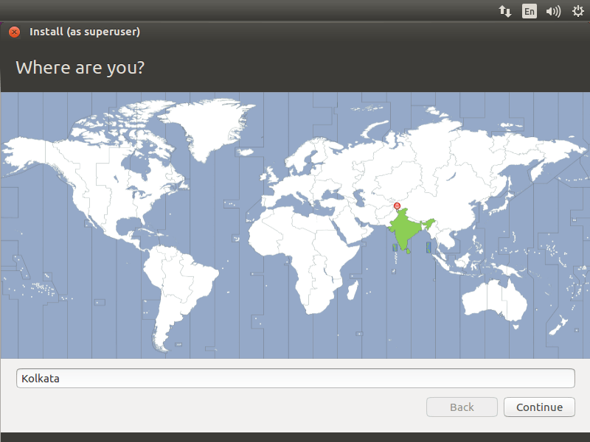

**Step 15:**

|  |
| --- |
| Select your keyboard layout. If you are not sure, use the ‘Detect Keyboard Layout‘ option. You can also test your selection by typing in the test text box. |

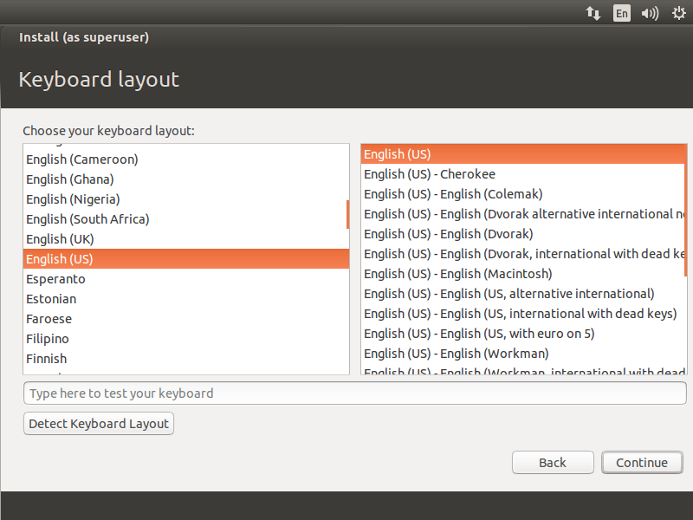

**Step 16:**

|  |
| --- |
| In the final screen of the installation wizard, you will be prompted to enter information about the user that you wanted to create on the system. Enter your information in this screen. Here is one thing you should remember – if you select ‘Login automatically‘,System will directly take you to the desktop without asking your credentials. It’s best if you give a very secure password for your installation. Ubuntu will tell you whether your password is secure or not. Once it’s done, click on continue. |

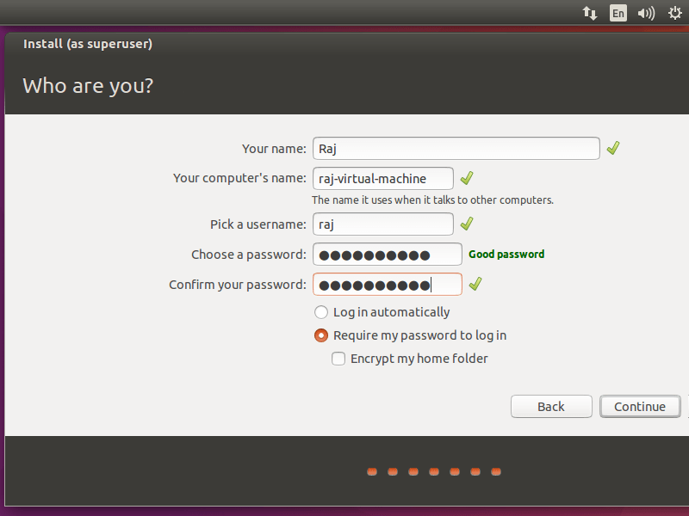

**Step 17:**

|  |
| --- |
| Below screenshot shows installing Ubuntu 16.04. |

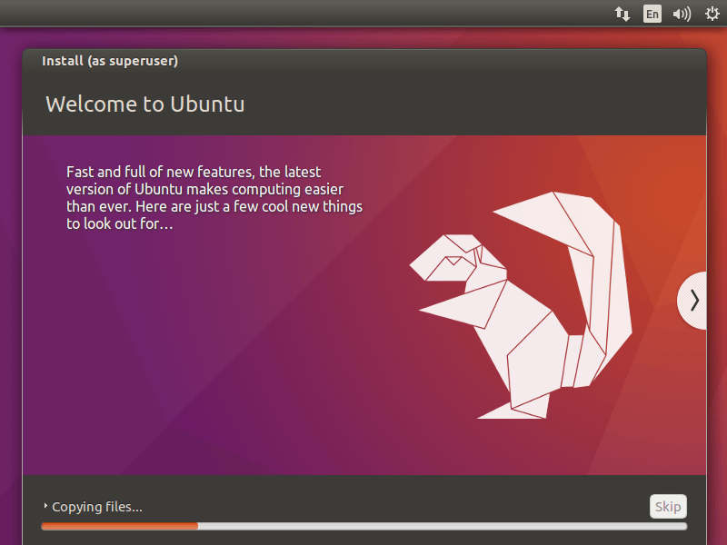

**Step 18:**

|  |
| --- |
| Once the installation is over, click on restart now. |

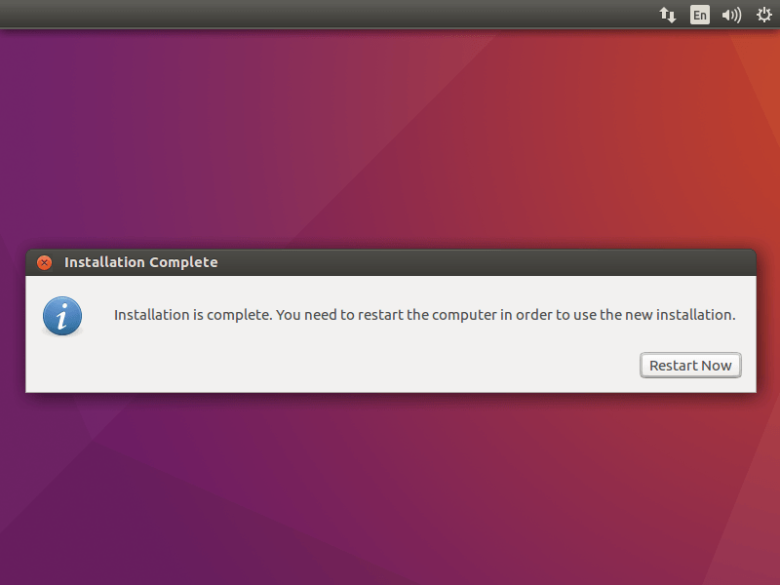

**Step 19:**

|  |
| --- |
| Once your machine is restarted, you will get a login window. Login with username and password that you created earlier. |

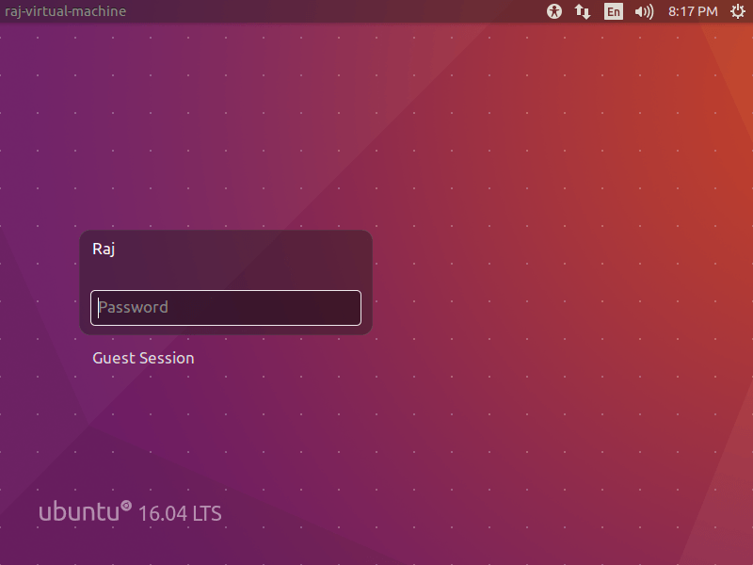

**Date : 07/12/2021 Teachers Signature:________________**